Animatic eye
AIM:
To design a vision based animatic eye for mimicking the eye movement of human when it detects a human face.
COMPONENTS:
SI.NO | COMPONENTS | QUANTITY | PRICE | COMPANY/SITE | ID
1 | Servo motor (SG90) | 06 | ₹ 94.00 | ROBU.IN | 5764
2 | Arduino uno | 01 | ₹ 439.56 | ROBU.IN | 6337
3 | Sensor Shield v5 | 01 | ₹ 83.00 | ROBU.IN | 26598
4 | Camera | 01 | ₹ 872.00 | ROBU.IN | 45666
5 | Battery | 01 | ₹ 891.00 | ROBU.IN | 1237659

PROCEDURE:
- Mount the SG90 servos securely inside the animatronic eye mechanism.
- Connect the servos to the microcontroller
- Set servos to 90° (center position) using a simple test code, ensuring the animatic eye face toward in its neutral resting position.
- Connect and configure the camera and run Python/OpenCV code to detect the user’s face and extract its (x, y) location in the camera frame.
- Upload/run the tracking algorithm, which converts the face position into smooth servo movement, allowing the animatronic eye to follow the target realistically.
CIRCUIT DIAGRAM:
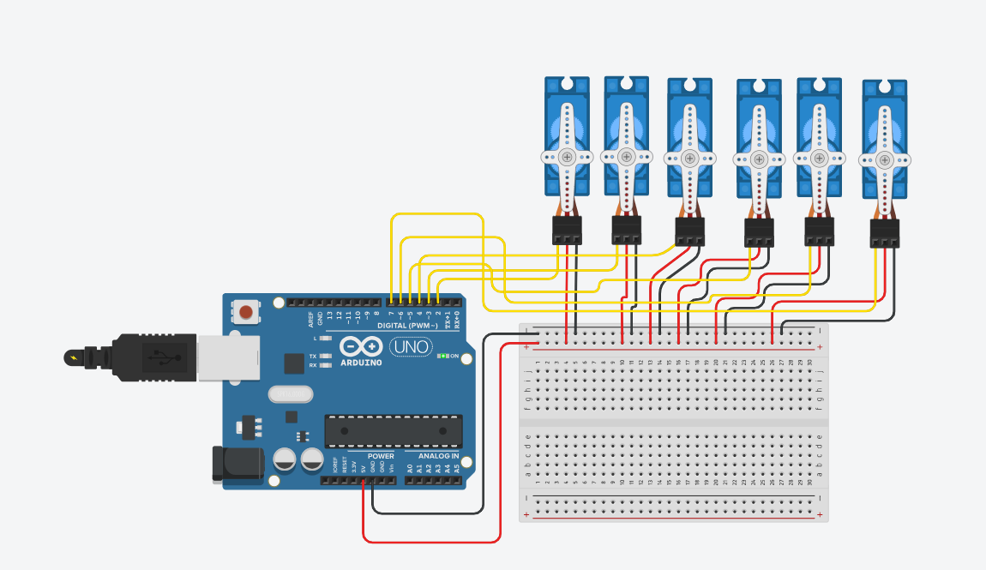
ALGORITHMS:
Start
- Initialize the eye servos and set them to the neutral 90° position.
- Start the camera stream and activate the face detection model (MediaPipe).
- Read a frame from the camera and find the x, y position of the detected target in the video feed.
- Compare the target’s position with the center of the camera view and rortate the servos to that position.
- Convert the detected target movement into smooth servo motion
- Apply movement limits to keep motion natural
- Send the updated angles to servos.
- Repeat Steps 3–7 continuously to maintain real-time tracking.

CODE:
Python:
import cv2
import serial
import time
import mediapipe as mp

# =============================================
# SERIAL COMMUNICATION
# =============================================
arduino = serial.Serial('COM5', 115200) # Change COM port
time.sleep(2)

# =============================================
# MEDIAPIPE FACE MESH INITIALIZATION
# =============================================
mp_face_mesh = mp.solutions.face_mesh
face_mesh = mp_face_mesh.FaceMesh(refine_landmarks=True)

# =============================================
# HELPER: Calculate Eye Aspect Ratio (Blink Detection)
# =============================================
import math
def distance(a, b):
return math.dist([a.x, a.y], [b.x, b.y])

def eye_aspect_ratio(landmarks, idx):
# Eye landmarks indices for blink detection
top = landmarks[idx[1]]
bottom = landmarks[idx[5]]
left = landmarks[idx[0]]
right = landmarks[idx[3]]

vertical = distance(top, bottom)
horizontal = distance(left, right)
return vertical / horizontal

# Mediapipe landmark indices for eye
RIGHT_EYE = [33, 159, 145, 133, 153, 144]
LEFT_EYE = [362, 386, 374, 263, 380, 373]

# =============================================
# CAMERA LOOP
# =============================================
cap = cv2.VideoCapture(0)

while True:
ret, frame = cap.read()
if not ret:
break

h, w = frame.shape[:2]

# Convert to RGB for mediapipe
rgb = cv2.cvtColor(frame, cv2.COLOR_BGR2RGB)
results = face_mesh.process(rgb)

if results.multi_face_landmarks:
mesh = results.multi_face_landmarks[0].landmark

# =============================================
# FACE POSITION FOR EYEBALL MOVEMENT
# =============================================
nose = mesh[1]
x = nose.x * w
y = nose.y * h

# Determine direction
if x < w * 0.40:
eye_dir = "LEFT"
elif x > w * 0.60:
eye_dir = "RIGHT"
else:
eye_dir = "CENTER"

if y < h * 0.40:
eye_vert = "UP"
elif y > h * 0.60:
eye_vert = "DOWN"
else:
eye_vert = "CENTER"

# =============================================
# BLINK DETECTION
# =============================================
ear_left = eye_aspect_ratio(mesh, LEFT_EYE)
ear_right = eye_aspect_ratio(mesh, RIGHT_EYE)

EAR = (ear_left + ear_right) / 2

blink = EAR < 0.20 # threshold

# =============================================
# SEND COMMANDS TO ARDUINO
# =============================================
command = f"{eye_dir},{eye_vert},{int(blink)}\n"
print("Sending:", command)
arduino.write(command.encode())

cv2.imshow("Animatronic Eye Control", frame)
if cv2.waitKey(1) == 27:
break

cap.release()
cv2.destroyAllWindows()

Arduino:

#include <Servo.h>

Servo rightUp;
Servo rightDown;
Servo leftUp;
Servo leftDown;
Servo eyeballH;
Servo eyeballV;

void setup() {
Serial.begin(115200);

rightUp.attach(3);
rightDown.attach(5);
leftUp.attach(6);
leftDown.attach(9);
eyeballH.attach(10);
eyeballV.attach(11);

centerEye();
}

void centerEye() {
eyeballH.write(90);
eyeballV.write(90);

rightUp.write(90);
rightDown.write(90);
leftUp.write(90);
leftDown.write(90);
}

void loop() {
if (Serial.available()) {
String data = Serial.readStringUntil('\n');

data.trim();
int c1 = data.indexOf(',');
int c2 = data.indexOf(',', c1 + 1);

String horizontal = data.substring(0, c1);
String vertical = data.substring(c1 + 1, c2);
int blink = data.substring(c2 + 1).toInt();

// ======================
// EYEBALL MOVEMENT
// ======================
if (horizontal == "LEFT") eyeballH.write(120);
else if (horizontal == "RIGHT") eyeballH.write(60);
else eyeballH.write(90);

if (vertical == "UP") eyeballV.write(120);
else if (vertical == "DOWN") eyeballV.write(60);
else eyeballV.write(90);

// ======================
// BLINK / EYELIDS
// ======================
if (blink == 1) {
// Closed eyes
rightUp.write(90);
rightDown.write(90);
leftUp.write(90);
leftDown.write(90);
} else {
// Open eyes
rightUp.write(140);
rightDown.write(50);
leftUp.write(40);
leftDown.write(130);
}
}
}

